How to use eseva on HTTPS

- Browser “GOOGLE CHROME “
Steps:
- Hit the link https://eseva.jharkhandcomtax.gov.in/Portal/
- Click on Advanced

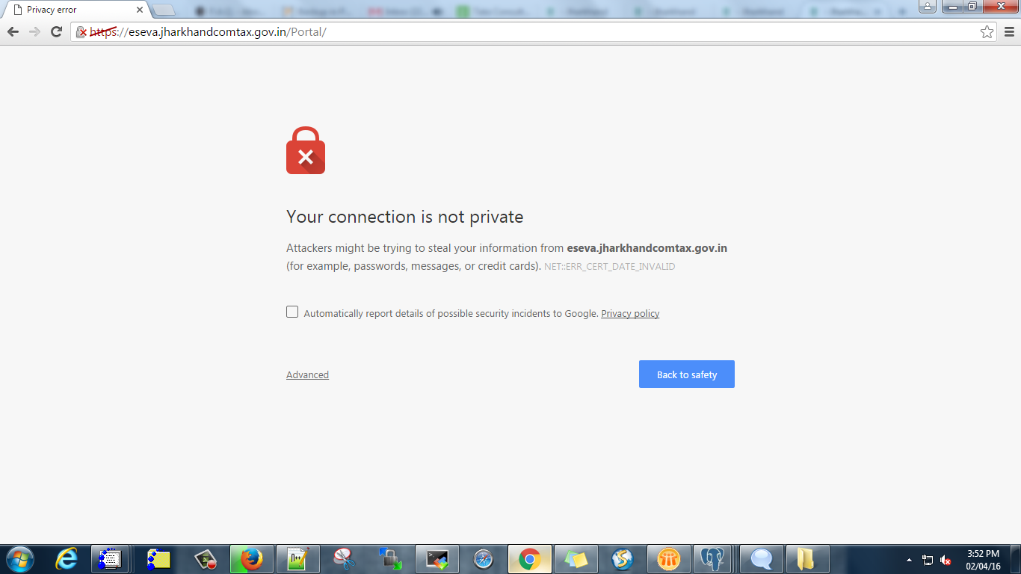

Click on Proceed to eseva.jharkhandcomtax.gov.in

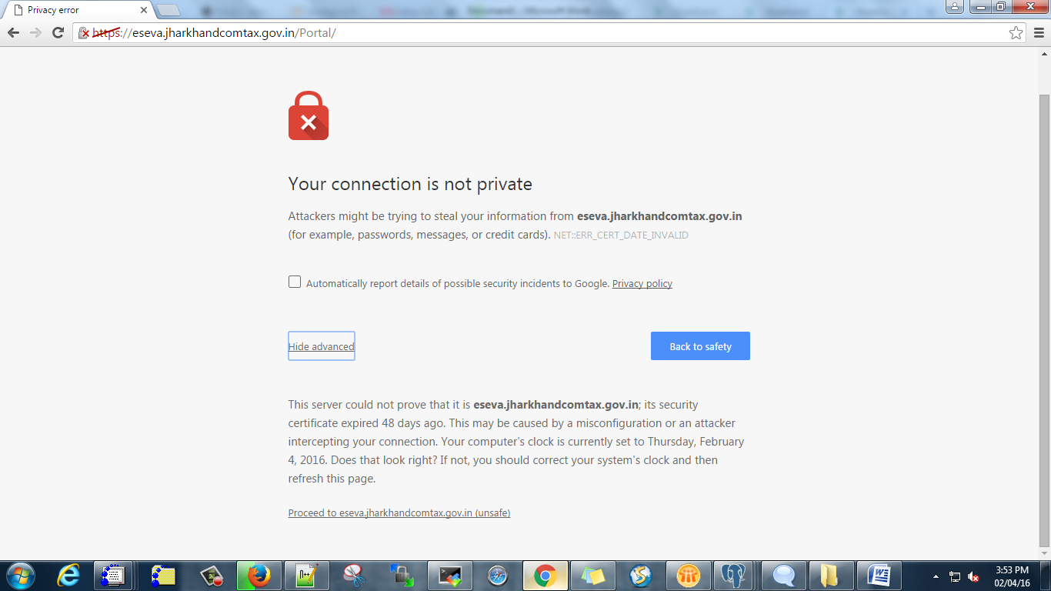

Now login
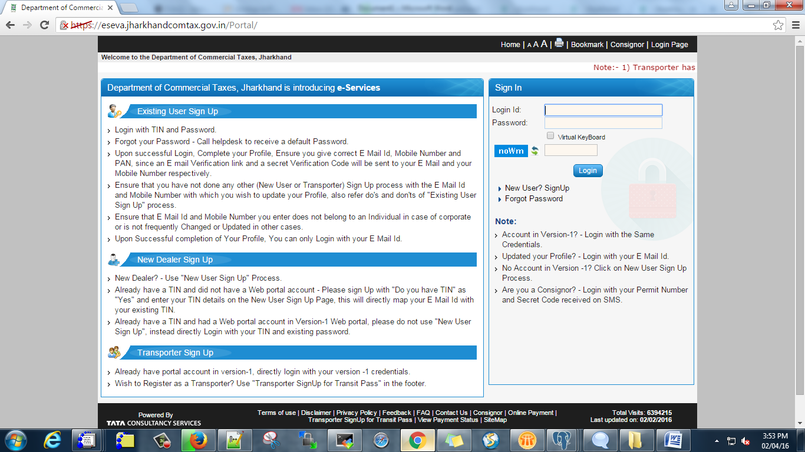

- Browser “MOZILLA FIREFOX “
- Hit the link https://eseva.jharkhandcomtax.gov.in/Portal/

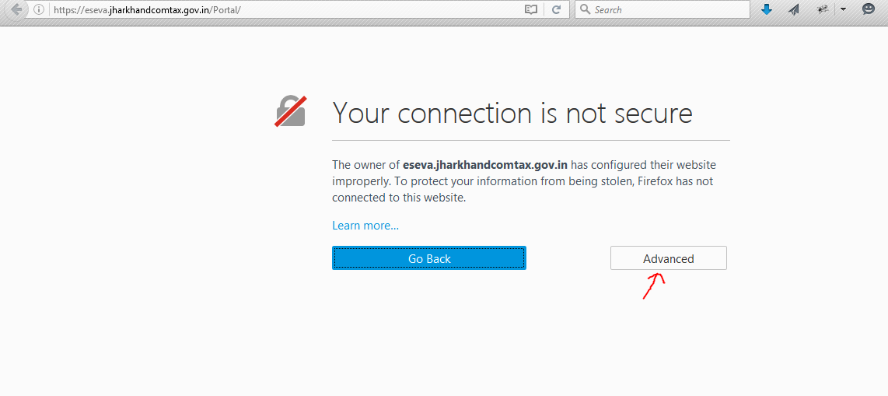

Click on Advanced

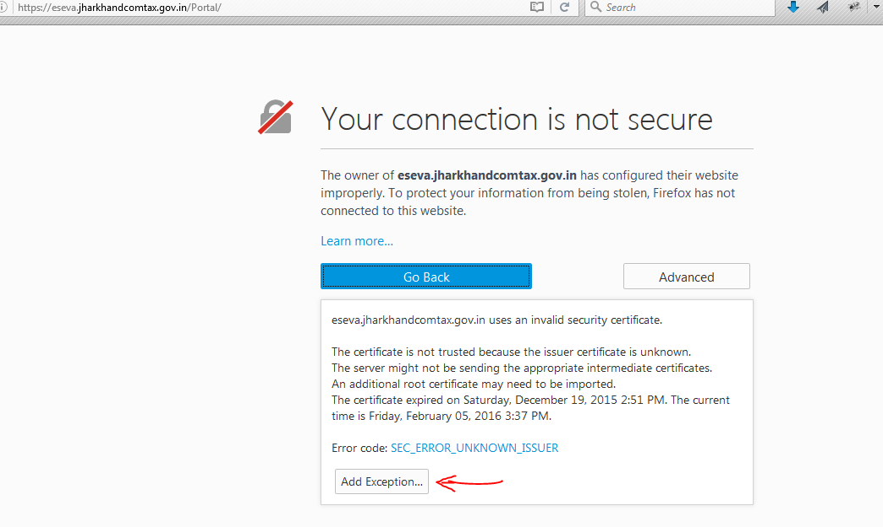

Click on Add Exception..

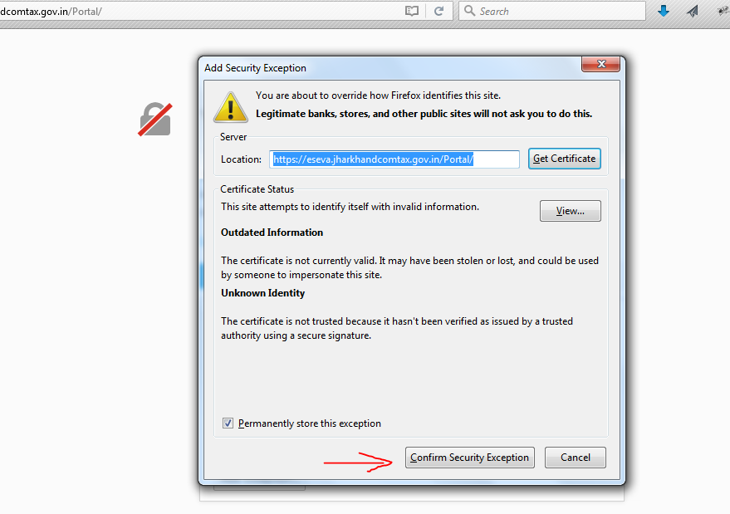

Click on confirm Security Exception

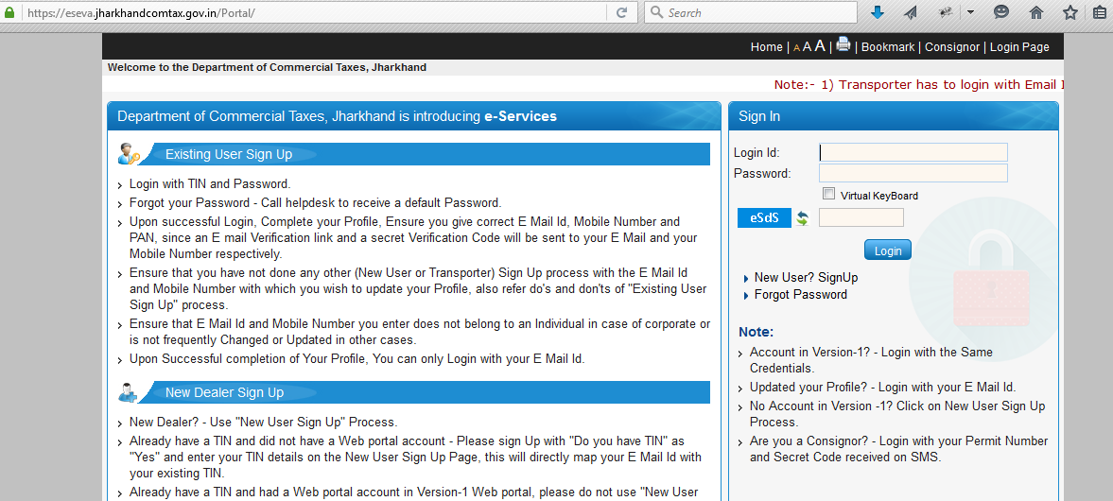

Now you can login.

