Compilation of Tweets
On
Application for Refund of Excess Amount from the Electronic
Cash Ledger and Refund of ITC Accumulated Due to Inverted
Tax Structure (RFD - 01A)

<< As on March 2018>>



Website: www.gst.gov.in Help Desk: - 0120-4888999
Email: helpdesk@gst.gov.in

Table of Contents

1. Application for Refund of Excess Amount From the Electronic Cash Ledger 3
i. How can I claim refund of excess amount available in cash ledger? 3
ii. What is the amount limit for claim of refund in case of “Refund of excess amount from the cash ledger”? 3
2. Refund of ITC Accumulated Due to Inverted Tax Structure (RFD -01A) 4
i. What is Inverted Tax Structure in the GST regime? 4
ii. What is needed to file for refund of accumulated ITC of IGST/CGST/SGST, export of goods? 4
iii. How can I file for refund on account of ITC accumulated due to Inverted Tax structure, and how will the disbursement be made? 5
iv. Is it mandatory to file GSTR-1, GSTR-2 and GSTR-3 in order to file for refund? 5
v. Is there any time limit to file for refund of ITC accumulated due to Inverted Tax Structure? 6
vi. In which bank account will the refund amount be credited? Is it one of the accounts that I registered in GST Portal? 6
vii. What is Net ITC? 7
viii. What is Turnover of inverted rated supply of goods? 7
ix. What is Tax payable on such inverted rated supply of goods? 8
x. What is Adjusted Total Turnover? 8
xi. What is the ‘SAVE’ feature in refund application? 9
xii. Where can I track my filed refund application? 9
xiii. I am not able to make any changes in the refund application? What could be the issue? 10
xiv. When is debit entry of refund amount claimed is made in ledger, while filing refund due to inverted duty structure? 10

Application for Refund of Excess Amount From the Electronic Cash Ledger

How can I claim refund of excess amount available in cash ledger?

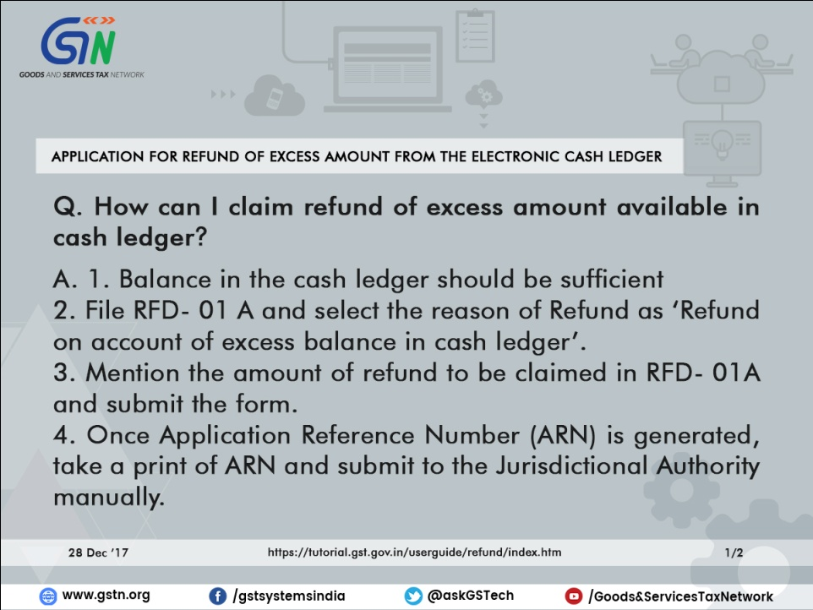

What is the amount limit for claim of refund in case of “Refund of excess amount from the cash ledger”?

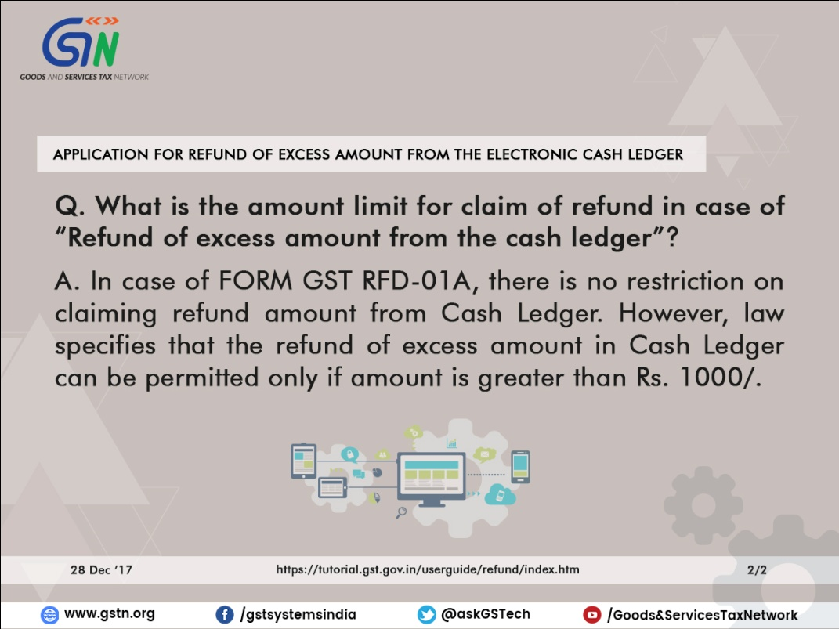

Refund of ITC Accumulated Due to Inverted Tax Structure (RFD -01A)

What is Inverted Tax Structure in the GST regime?

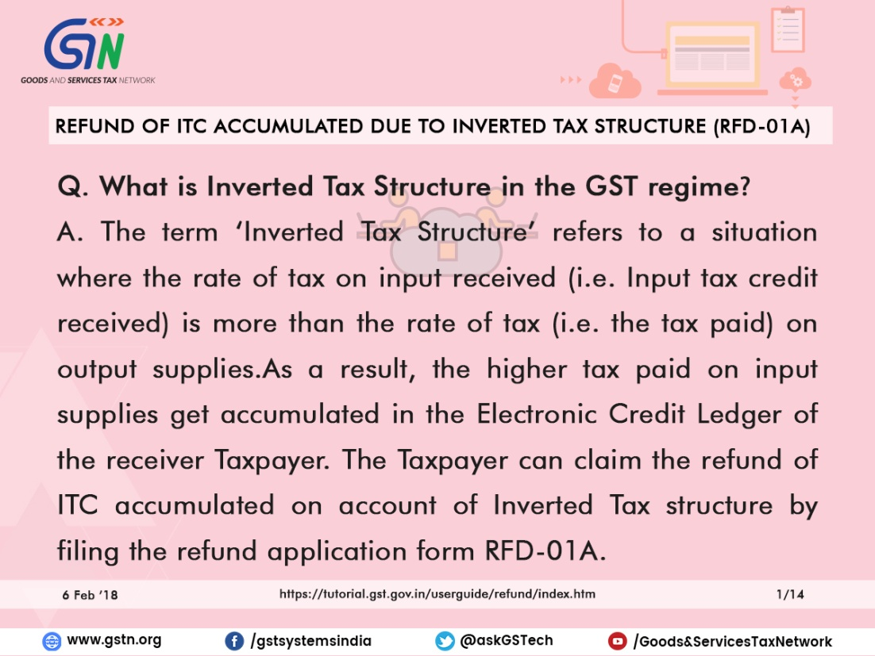

What is needed to file for refund of accumulated ITC of IGST/CGST/SGST, export of goods?

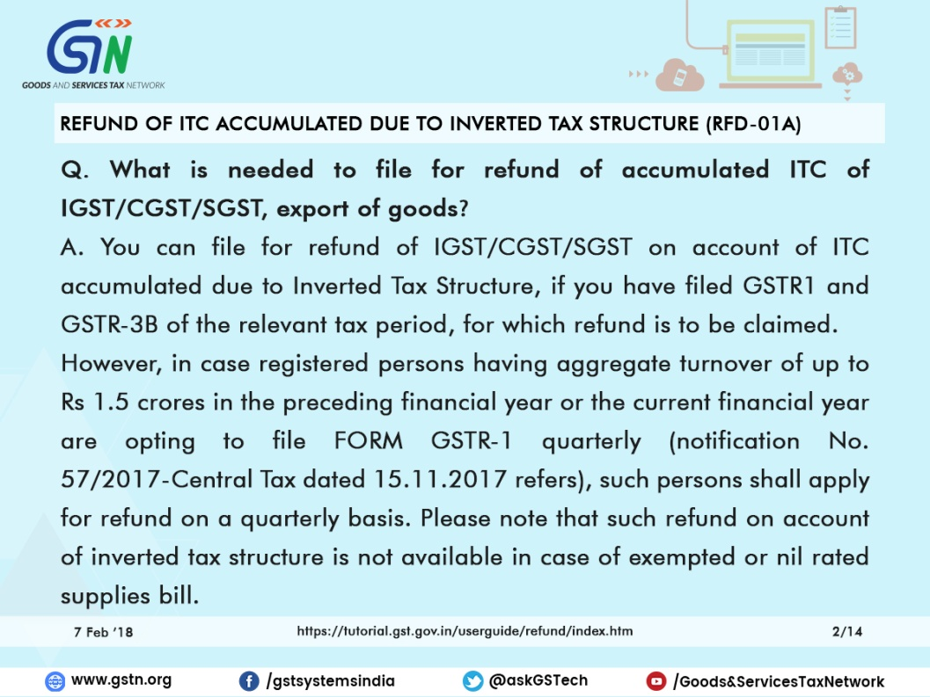

How can I file for refund on account of ITC accumulated due to Inverted Tax structure, and how will the disbursement be made?

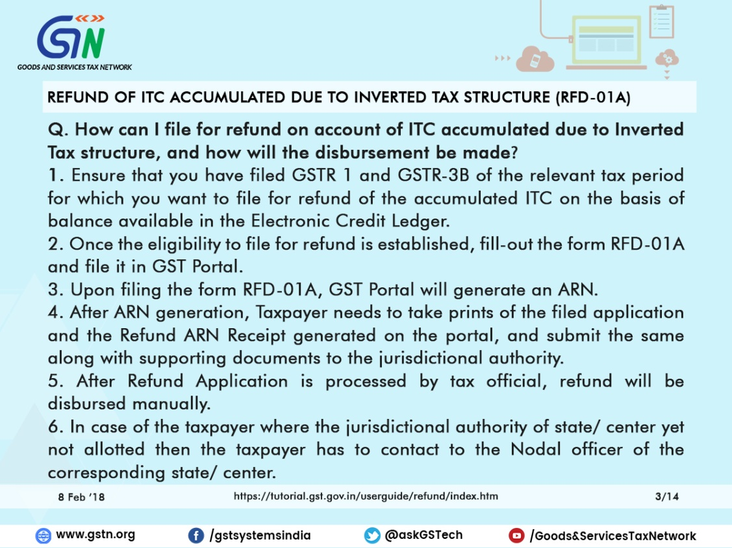

Is it mandatory to file GSTR-1, GSTR-2 and GSTR-3 in order to file for refund?

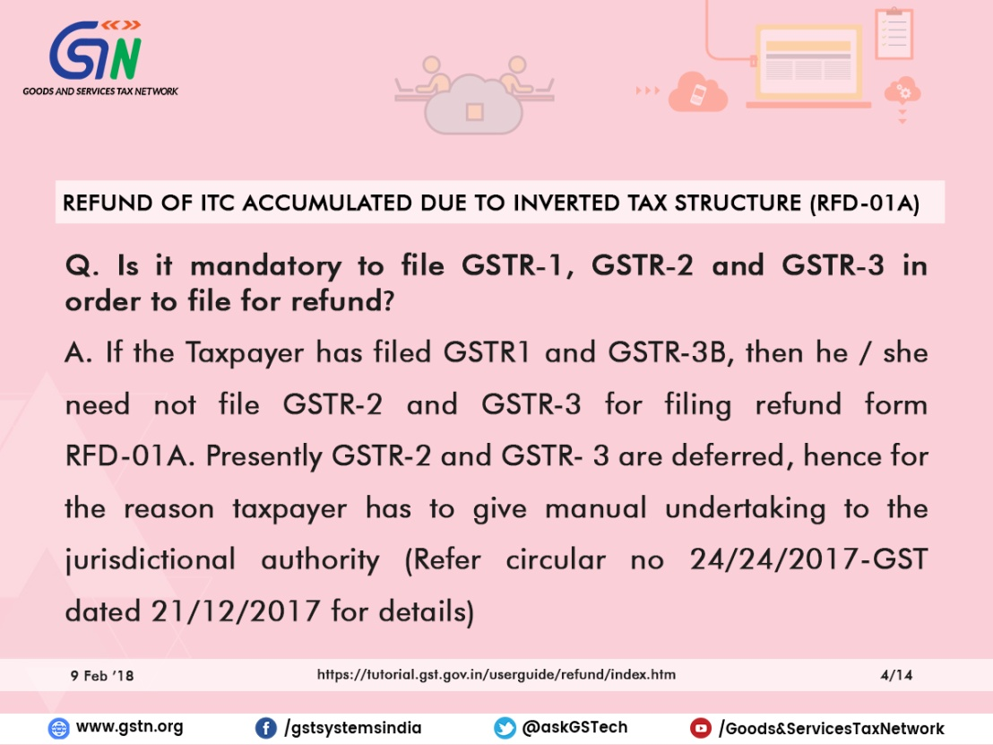

Is there any time limit to file for refund of ITC accumulated due to Inverted Tax Structure?

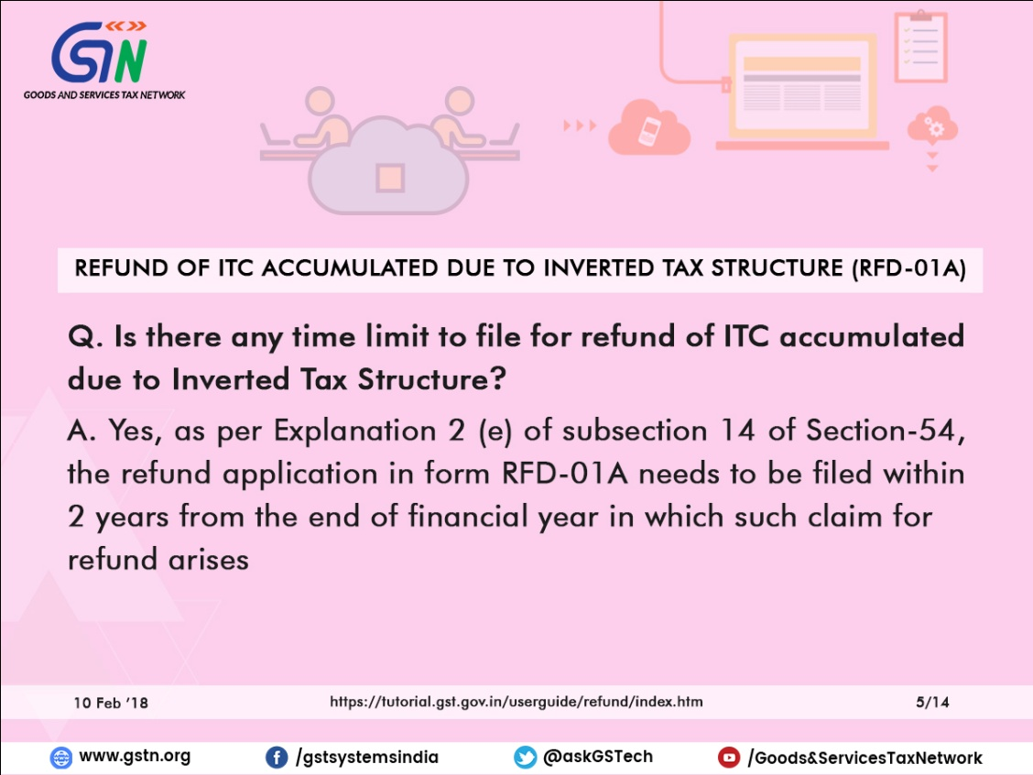

In which bank account will the refund amount be credited? Is it one of the accounts that I registered in GST Portal?

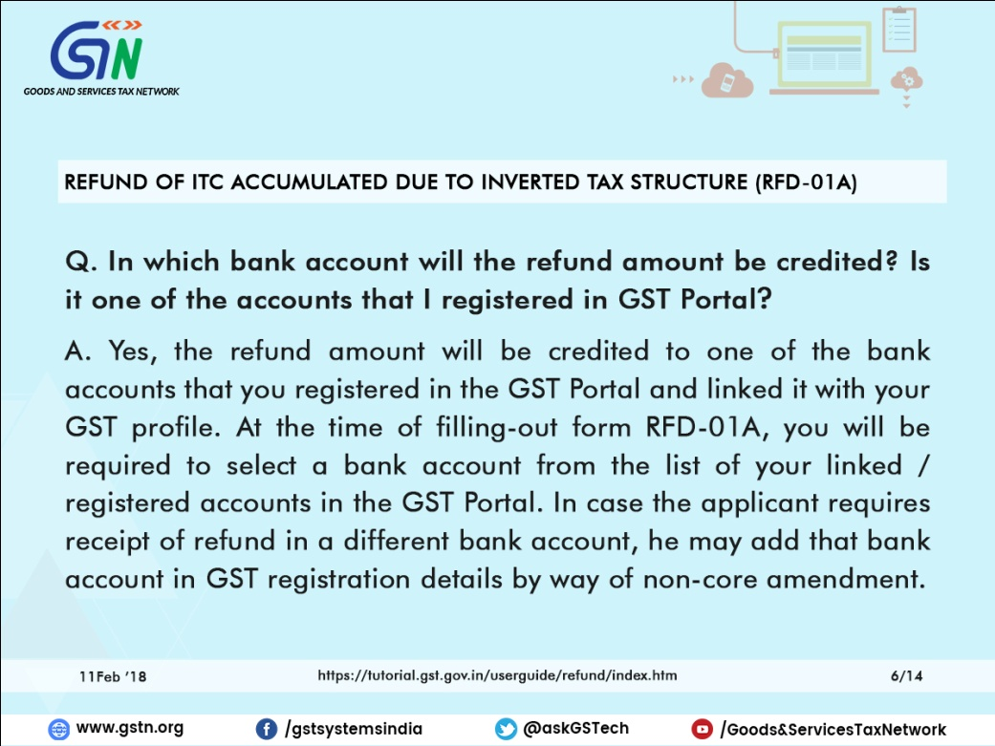

What is Net ITC?

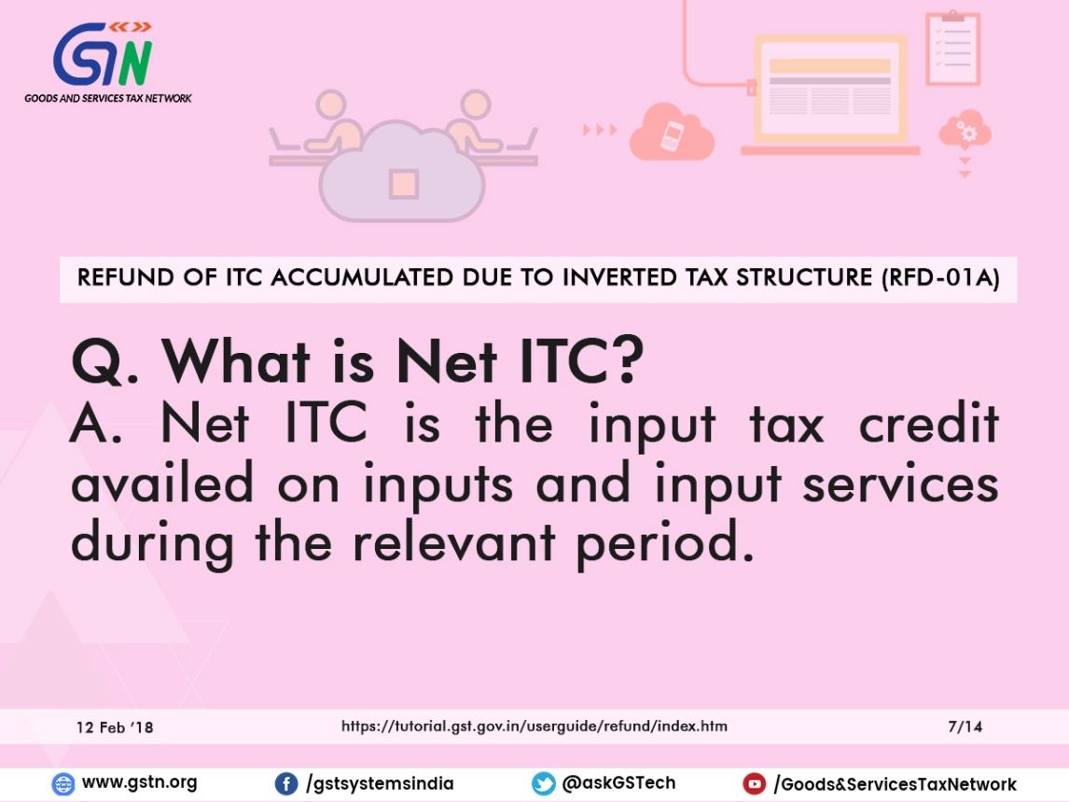

What is Turnover of inverted rated supply of goods?

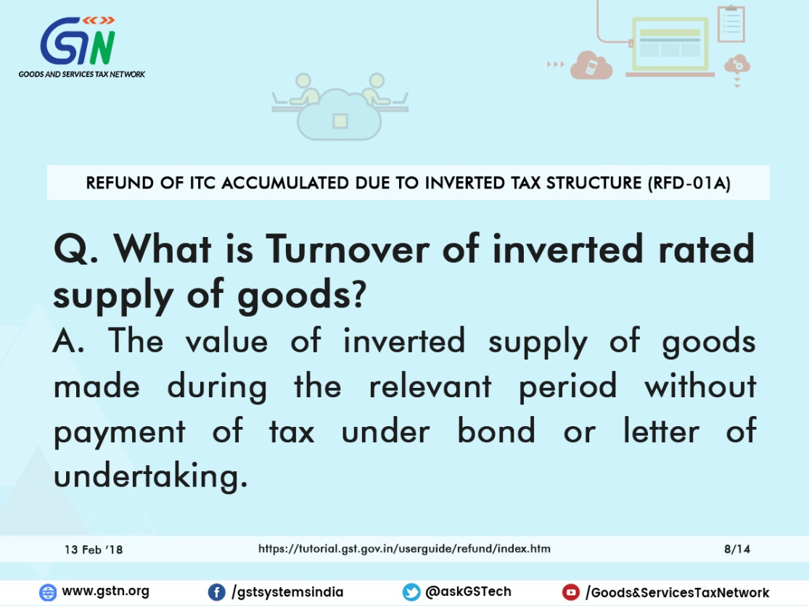

What is Tax payable on such inverted rated supply of goods?

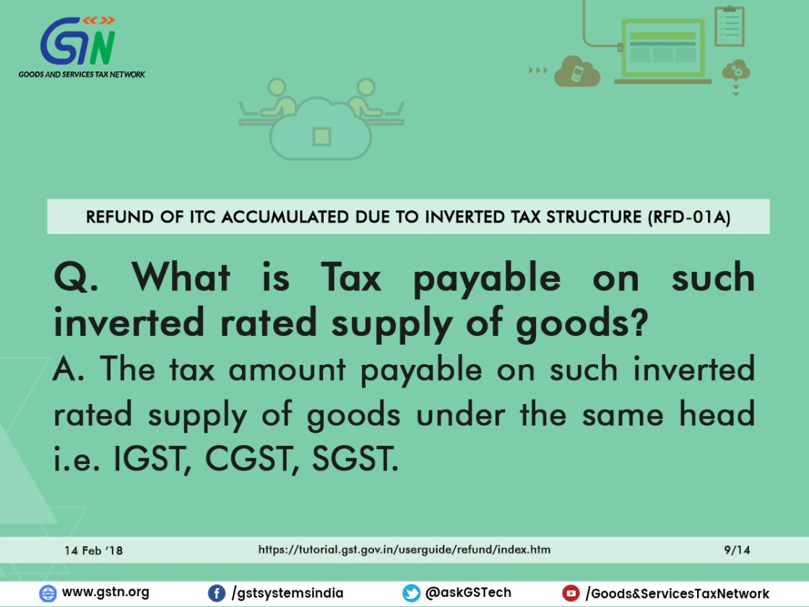

What is Adjusted Total Turnover?

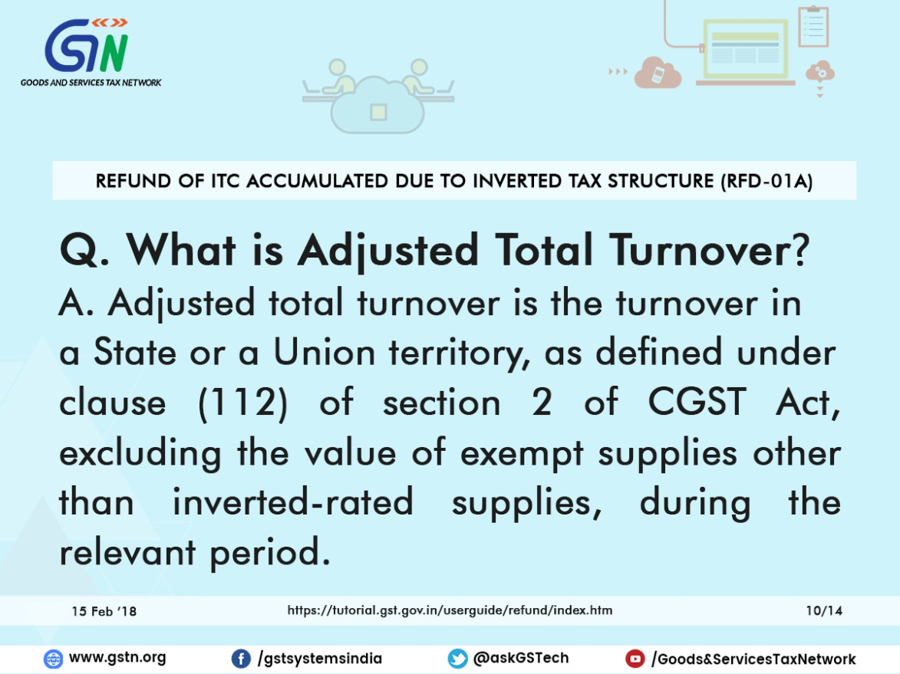

What is the ‘SAVE’ feature in refund application?

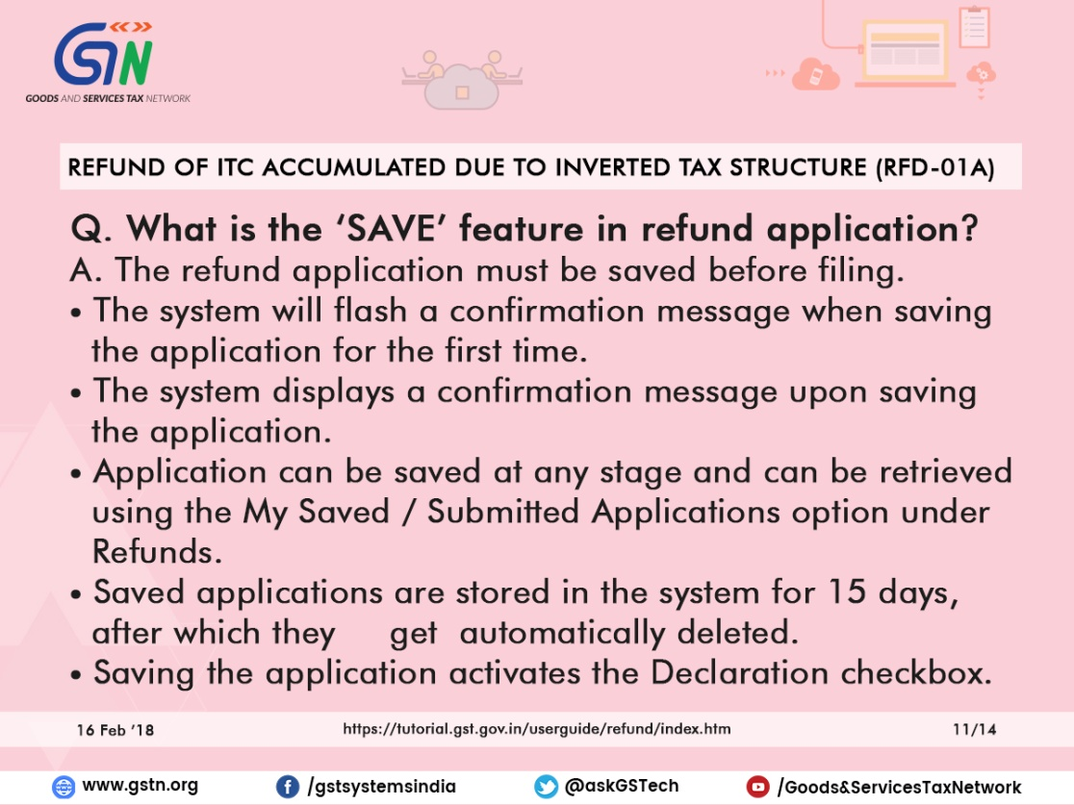

Where can I track my filed refund application?

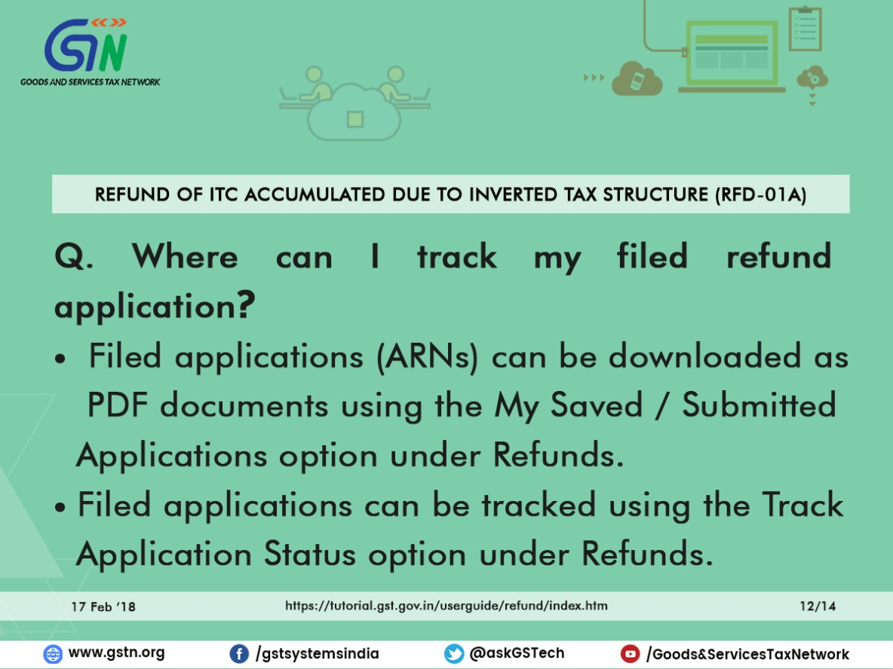

I am not able to make any changes in the refund application? What could be the issue?

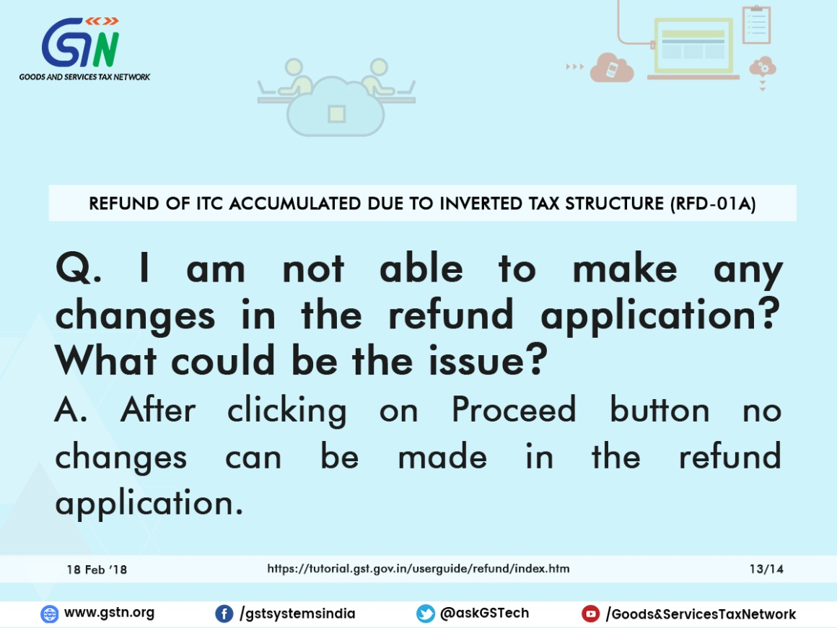

When is debit entry of refund amount claimed is made in ledger, while filing refund due to inverted duty structure?

