Compilation of Tweets
On
Refund application for IGST Paid on Export of Goods and
Refund on Account of Export of Goods (With Payment of Tax)

<< As on March 2018>>



Website: www.gst.gov.in Help Desk: - 0120-4888999
Email: helpdesk@gst.gov.in

Table of Contents

1. Steps to file Refund application for the IGST Paid on Export of Goods 3
2. Refund on Account of Export of Goods (With Payment of Tax) 4
i. Am I eligible to receive the refund of IGST paid on export of goods if I have filed GSTR-3B? 4
ii. How can I claim refund on account of Export of Goods (with Payment of Integrated Tax)? When the refund will be processed? 4
iii. I have received SMS and e-mail from GST Portal regarding disbursal. I need further details regarding amount that has be refunded. Whom should I contact? 5
iv. Whether GSTR-2 and GSTR-3 need to be filed for claiming the refund? 5
v. If I miss Shipping and Invoice details in a month, can I add the details in the subsequent months and get refund? 6
vi. In which bank account, will the refund amount be credited? Whether the bank account will be the account I entered in my enrolment/registration form? 6

Steps to file Refund application for the IGST Paid on Export of Goods

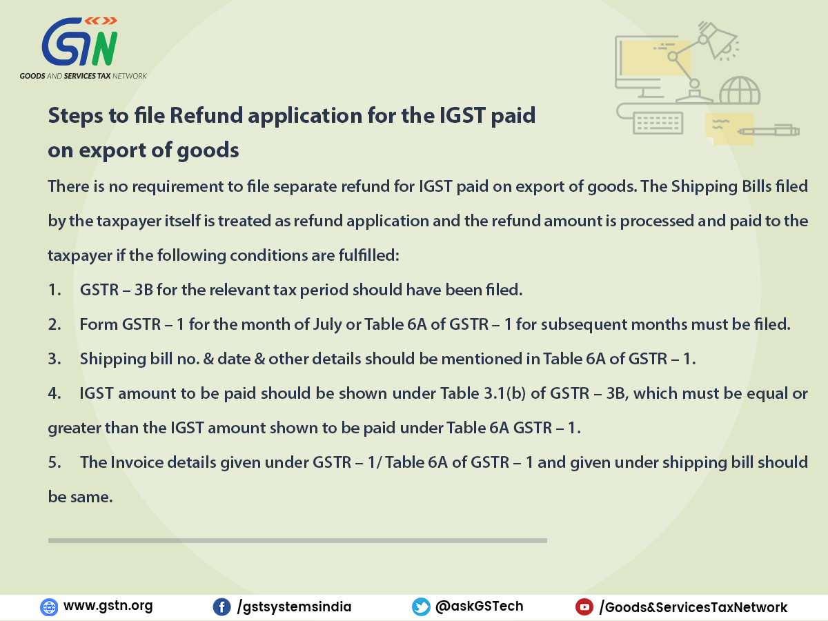

Refund on Account of Export of Goods (With Payment of Tax)

Am I eligible to receive the refund of IGST paid on export of goods if I have filed GSTR-3B?
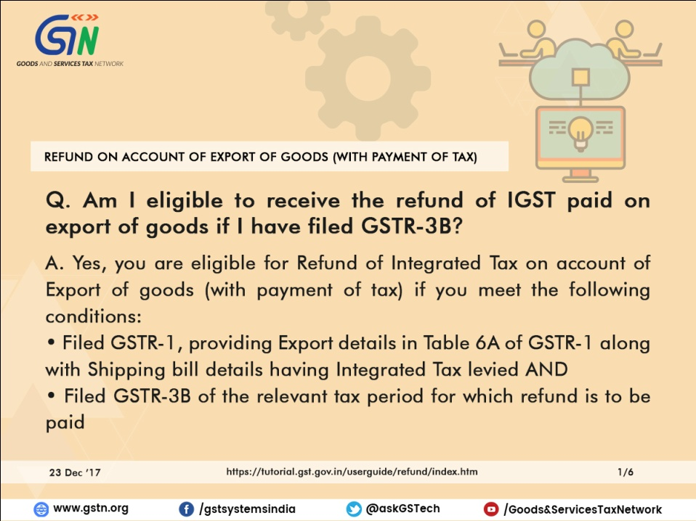

How can I claim refund on account of Export of Goods (with Payment of Integrated Tax)? When the refund will be processed?

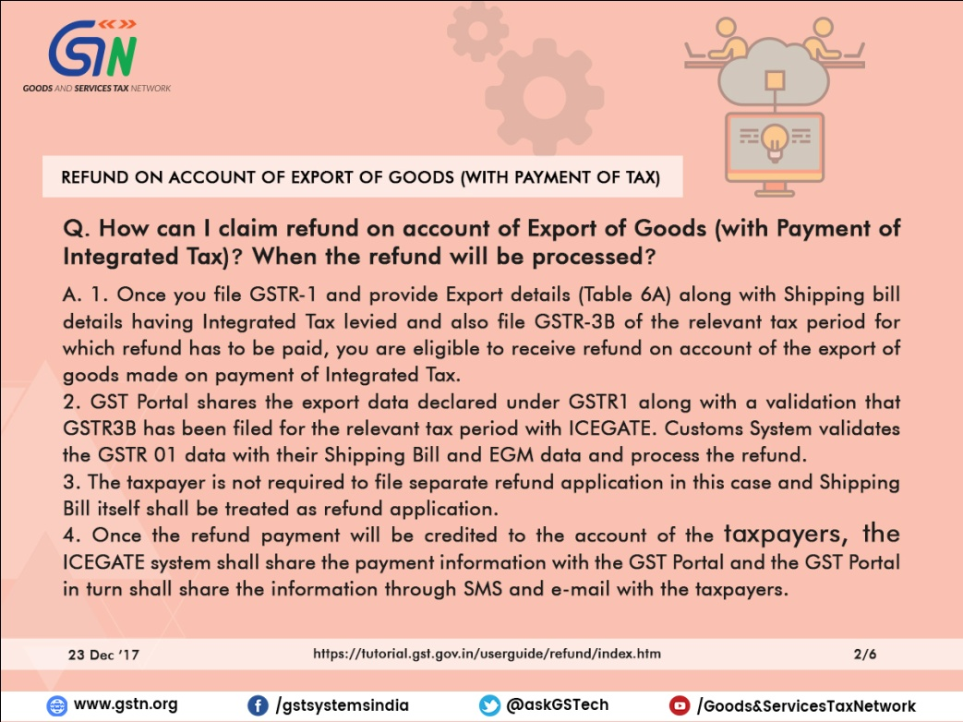

I have received SMS and e-mail from GST Portal regarding disbursal. I need further details regarding amount that has be refunded. Whom should I contact?

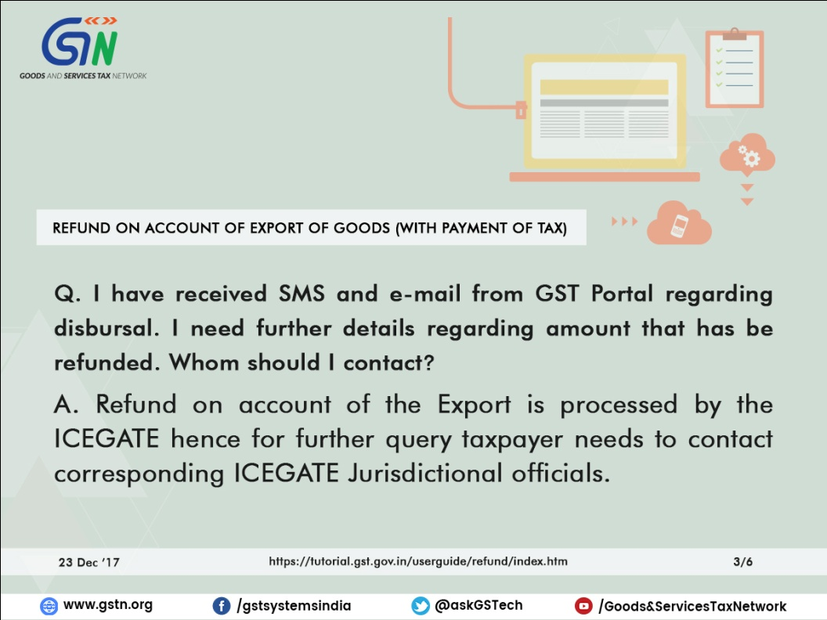

Whether GSTR-2 and GSTR-3 need to be filed for claiming the refund?

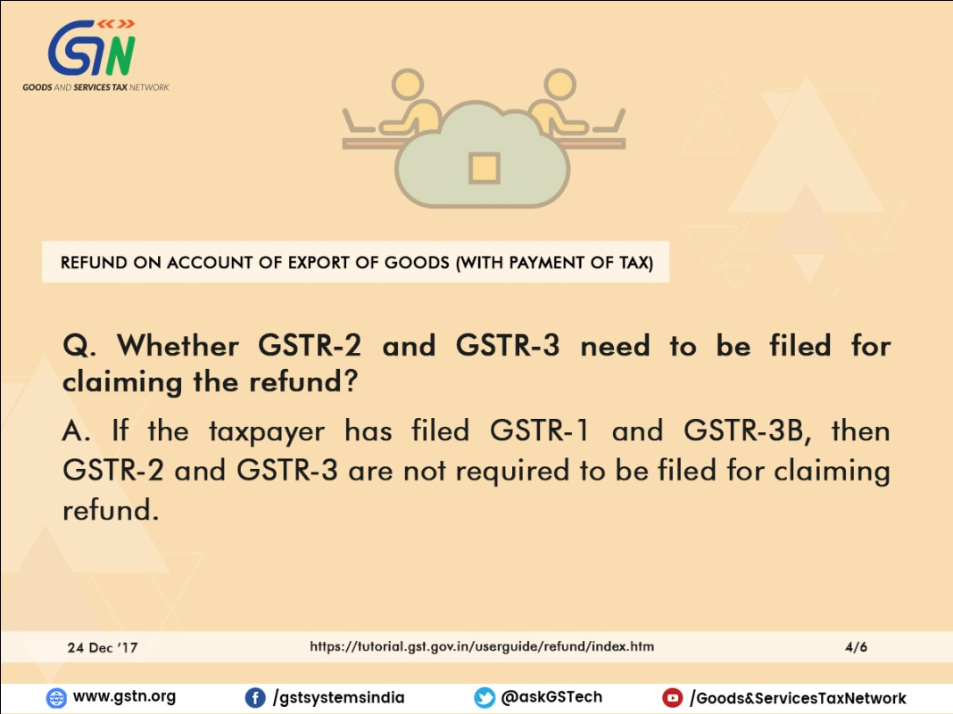

If I miss Shipping and Invoice details in a month, can I add the details in the subsequent months and get refund?

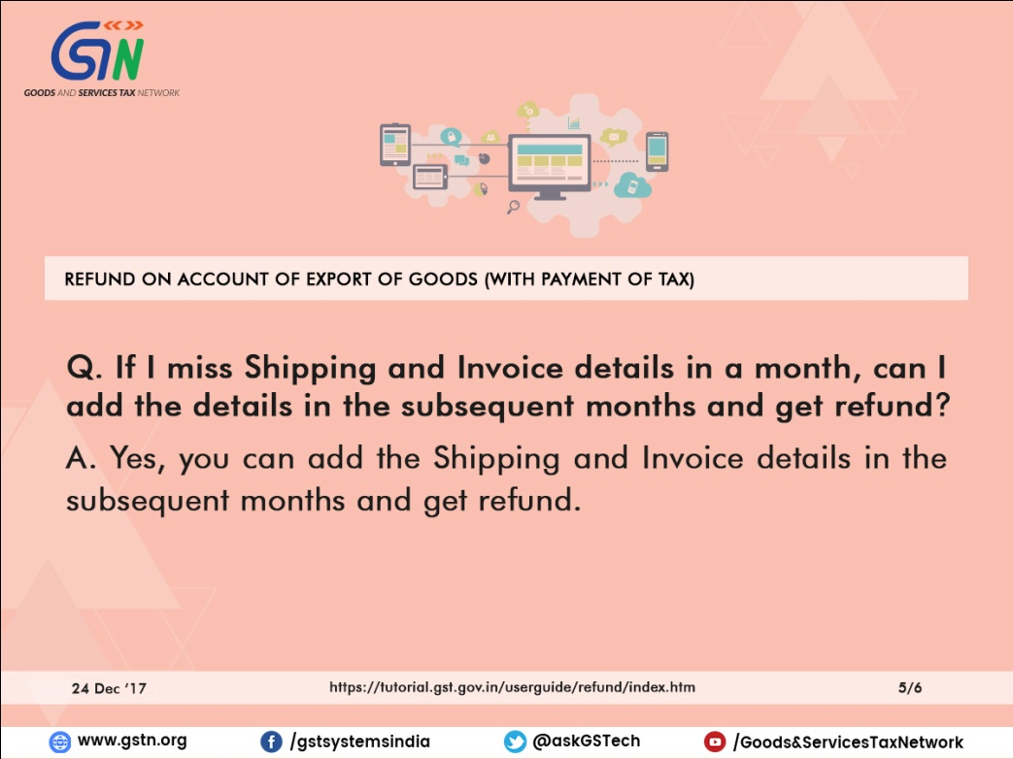

In which bank account, will the refund amount be credited? Whether the bank account will be the account I entered in my enrolment/registration form?

